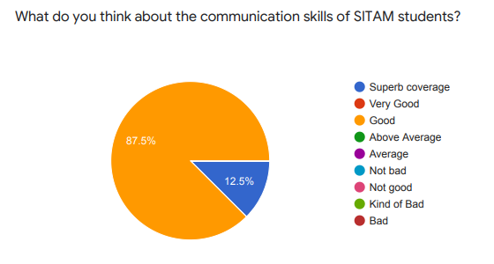
Action Taken:
- Conducted More Seminars/ workshops regarding communication skills.
- Made the students to participate in several intra and inter-college events.
- One student in the class is encouraged to speak for a few minutes about the lesson learnt the previous day. This would foster continuous learning as well as oratory skills.
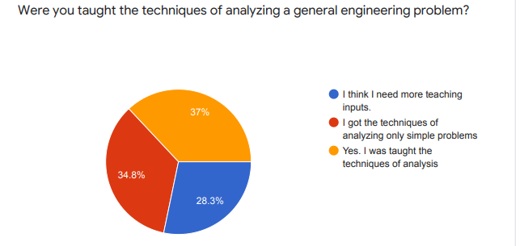

Action Taken:
- Open ended problems are posed to make the students think.
- Small project works are encouraged to enhance real-life exposure.
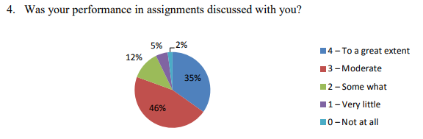
- Arranged several industrial visits.

Action Taken: Teachers take care to discuss the lacunae of students in one-on-one discussions
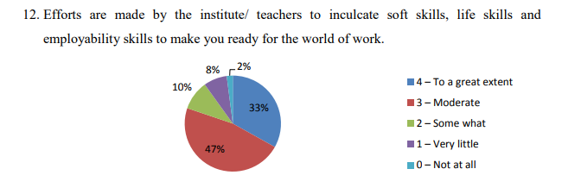
Action Taken:
- Students are encouraged to organize seminars with least intervention from the teachers.
- Innovation Center was created.
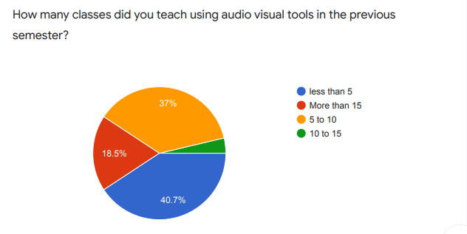
- Made more MoUs with different industries

Action Taken:
- Arranged more class rooms with Projectors

